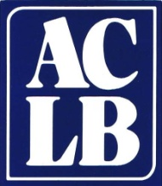
Association of Connecticut Library Boards
c/o Connecticut State Library
231 Capitol Avenue Hartford, CT 06106
www.aclb.org info@aclb.org
(860) 757-6665

Membership Application 2022
Membership year: January – December

Membership Category (Check one)

□ Individual ($35 Annual Fee) □ Institution* ($100 Annual Fee)

* Institution fee covers all library board/institution members.

Contact Person or Individual Applicant
Position or Title
Telephone _______________ Mobile _______________ E-mail ______________________
Name of Institution
Mailing Address
City _______________________________________ State ______ Zip

ACLB maintains a listserv for trustees called ACLB Trustee-Talk. We will not distribute our e-mail list to any outside parties and will use the list only for relevant communication with ACLB members.

Amount remitted: _____________

□ Check if you are interested in becoming a board or committee member.

Fill out this form and forward with payment (made out to ACLB) to:
Association of Connecticut Library Boards
c/o Connecticut State Library
231 Capitol Avenue
Hartford, CT 06106
Questions? E-mail aclbctinfo@gmail.com or call (860) 757-6665

